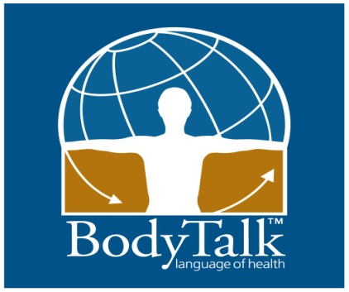
3 KEY CONCEPTS
These are important features of the BodyTalk System that make it unique.
NEUROMUSCULAR BIOFEEDBACK TO ESTABLISH PRIORITY
Certified BodyTalk Practitioners use an energetic biofeedback technique by using a form of muscle testing for a ‘yes’ or ‘no’ response to facilitate a conversation with the client’s innate wisdom. This biofeedback technique is one way to tap in to this unspoken universal language of the body. Together we follow a linear protocol chart to determine what needs to be addressed first and in which sequence – like connect the dots - whether consciously aware of the priority or not we get to bring a picture into focus for expanded awareness. By utilizing the art and science of this biofeedback technique, the client’s innate wisdom is in command of the session, not the Practitioner and we get to surface issues that the conscious mind may be blocking. For this reason BodyTalk sessions can be implemented in person or at a distance.
THE TAPPING PROCESS
All BodyTalk techniques rely on a very light tapping process to bring them into effect: tapping over the head and tapping over the heart. The light tapping is used to facilitate the communication required from brain to body, and to store the memory of the changes that are being made.
When we just tap the head on its own, nothing significant seems to happen. When we tap the head while we are linking parts of the body as indicated by innate wisdom as in the surfaced BodyTalk “formulas” a great deal happens. The tapping on the head over both hemispheres seems to activate the brain centers in a way that causes the brain to consciously re-evaluate the state of health in the body-mind in relation to the priority that is being isolated.
The rest of the body then readjusts to that correction and a chain of events is set up to bring about balancing and repair to the whole system. This repair is holistic in that the body-mind seems to address multiple factors associated with the original imbalance. It appears when we establish points that need to be linked, and tap the head; we are, essentially, asking the brain to fix the problem.
The tapping of the sternum appears to correspond to the energetic relationship to the heart complex. This technique relates more specifically to the concept of the heart energies. There is significant evidence to show that the heart, in addition to its role of pumping blood, plays a significant role in the distribution of energy in the body. The heart ‘pumps’ patterns of energy and information to every cell in the body, storing the memory of changes being made. Tapping on the body to get it to focus on healing has been used by many indigenous holistic systems, such as Hatha Yoga for centuries.
When an imbalance has been pointed out the brain will recognize that something needs to be shifted and make the necessary corrections. It should be noted that when parts of the body that are not out of balance are touched for linking and we tap the head, nothing will happen. This means that if the “wrong” technique is applied and tapped out, no harm is done to the person. You can tap your own head and heart in remote distance sessions and receive the same benefits as an in-person BodyTalk session. Because the client’s innate wisdom is dictating the session, the client is assured of receiving exactly what they need at that time.
EXAGGERATED BREATHING
Deep breathing is important for a number of reasons. Just getting more oxygen into the body can improve health on its own. Oxygen is vital to every cell in producing energy for all biochemical reactions. The more oxygen is available, the more energy can be created.
Each time we breathe in and out, the brain scans all of the frequencies of the body. As we breathe out, the scanning goes to the lower frequencies – represented by muscle, connective tissue and bone. As we breathe in, the brain scans higher energy frequencies including thoughts and emotions. The brain is able to ‘see’ where the imbalances are and makes the energetic corrections to those areas. Exaggerated breathing is also often used to help the body locate and target the corrections. The brain uses the breath cycle to scan the body.
During this time, the client is usually in a state of relaxation, is kept informed of the protocols being used and is involved in the process of “tapping out.” You are asked to breathe deeply in and out while the BodyTalk techniques are being tapped out over the head and heart. It has been demonstrated that by controlling breath it is possible to control the beating of the heart as well as to calm the mind. This is very important in BodyTalk because we utilize these relationships to bring about lasting changes through the tapping process.
FURTHER EXPLORATION
For more information on BodyTalk, including instructional video on the Cortices Technique, visit www.bodytalksystem.com or call Jessica Ardeal, CBP at 1-877-75-PEACE

